Experiment:18 Date:1/08/2027

Prolog Program to Sum Integers from 1 to N

Aim:
To write a Prolog program to find the sum of integers from 1 to N.

Algorithm:
- Start the program.
- Read the value of N.
- Check whether N is zero.
- Recursively calculate the sum from 1 to N-1 and add N.
- Display the final sum and stop.

PROGRAM:
sum_to_n(0, 0).
sum_to_n(N, Sum) :-
N > 0,
N1 is N - 1,
sum_to_n(N1, S),
Sum is N + S.

OUTPUT:
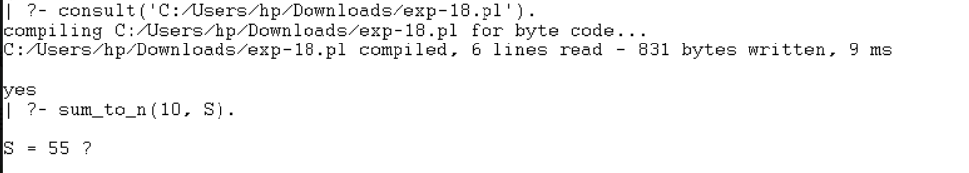

RESULTS:
Thus, the Prolog program was successfully executed to calculate the sum of integers from 1 to N.

